Mark Galesi

Assignment 1:Echo UDP Trace Output

Test One(server responds)-Client: 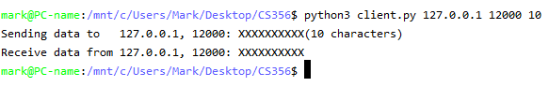

Test One(server responds)-Server:

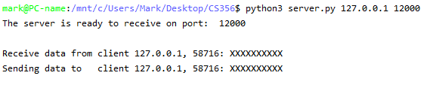

Test Two(server doesn’t respond)-Client: